产品目录

直放
PA10001500_33(2W)
PA11001260_40(10W)
PA12001260_40(10W)
PA12001600_40(10W)
PA12681624_40(10W)
PA14201454_27(0.5W)
PA15001700_50(100W)
PA19301990_45(32W)
PA21102170_34(2W)
PA869960_30(1W)
PA18051990_30(1W)
PA21102170_47(60W)
PA24002480_40(10W)
PA24002500_50(100W)
PA26002700_37(5W)
PA26002700_45(32W)
PA340470_33(2W)
PA450600_33(2W)
PA57005900_42(15W)
PA57005850_50(100W)

TDD 双向放大器
TDD24002500_33(2W)
TDD24002500_27(0.5W)_1T2R
TDD24002500_40(10W)
TDD34003600_37(5W)
TDD750790_43(20W)
TDD890935_37(5W)
LTE18801920_40(10W)
LTE23002400_40(10W)
LTE25802620_40(10W)

移频放大器
TDDSF335345_40(10W)

PA10001500_33(2W)
Operating Frequency：1000MHz～1500MHz
Transmit Gain)：13 ± 1dB
Small Signal Gain Flatness：≤2.0dB
Gain stability：± 1.50dB
Launch Output： 33dBm (2W @COFMD modulation)
Power Consumption：Average current 1.5A @ DC 12V
ON/OFF Control：3.3v High Level
Dimensions： 90 x 48.5 x 14 (mm)
Operating Temp.： -20℃ ～ +60℃
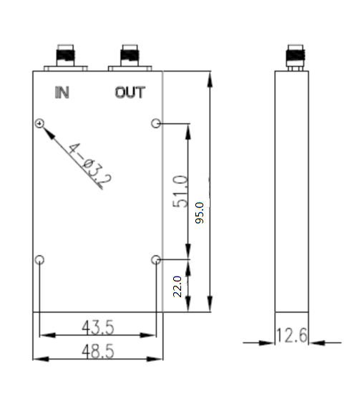
Weight： 150g

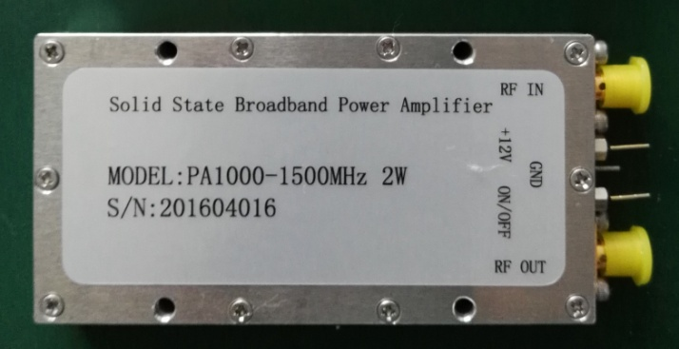

PA11001260_40(10W)
Frequency Range：1100～1260MHz
Launch Output：≥40dBm
Gain：≥40dB
Small Signal Gain Flatness：±1dB
Launch Power Input：Min. 0dBm
Input VSWR：≤2:1
Efficiency：≥20%
Harmonics:≥60dBc
Input/Output impedance：50 Ohm
Supply Voltage：12V-14V
Operating Temp. ：-20℃～ +60℃
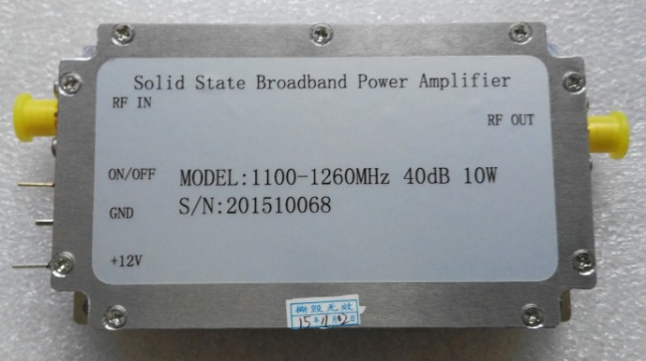
Dimensions：120*58*20(mm) 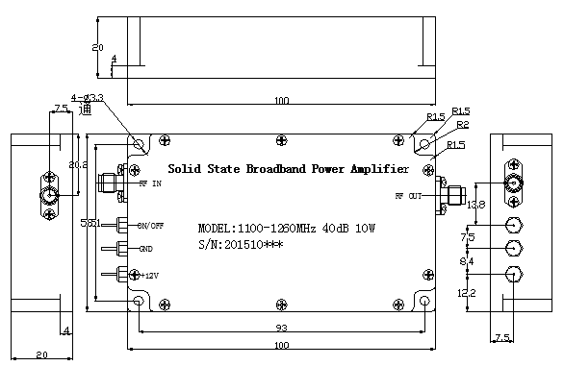

PA12001260_40(10W)
Frequency Range: 1200 ～ 1260 MHz
Launch Output：≥40dBm
Gain：≥40dB
Small Signal Gain Flatness：Peak to Peak 2dB
Launch Power Input：Min. 0dBm
Input VSWR：≤2:1
Efficiency：≥20%
Harmonics:≥60dBc
Input/Output impedance：50 Ohm
Supply Voltage：12V-14V
Operating Temp.：-40℃ ～ +60℃
Dimensions：120*58*20(mm)
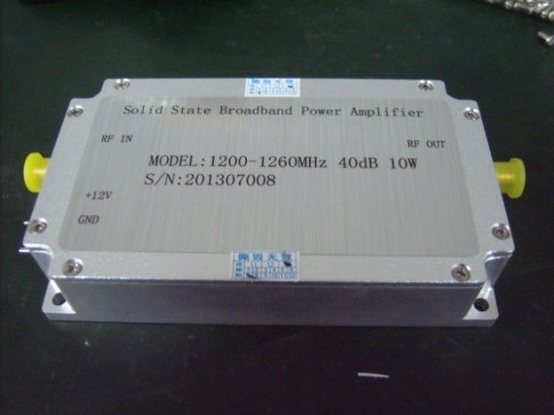

PA12001600_40(10W)
Frequency Range: 1200 ～ 1600 MHz
Launch Output：≥40dBm
Gain：≥40dB
Small Signal Gain Flatness：Peak to Peak 2dB
Launch Power Input：Min. 0dBm
Input VSWR：≤1.5:1
Input/Output impedance：50 Ohm
Power Consumption: 2.5A @ DC 12V
ON/OFF Control：ON/Low Level or GND;OFF/High Level
Operating Temp.：-40℃ ～ +60℃
Dimensions：100*60*20(mm)
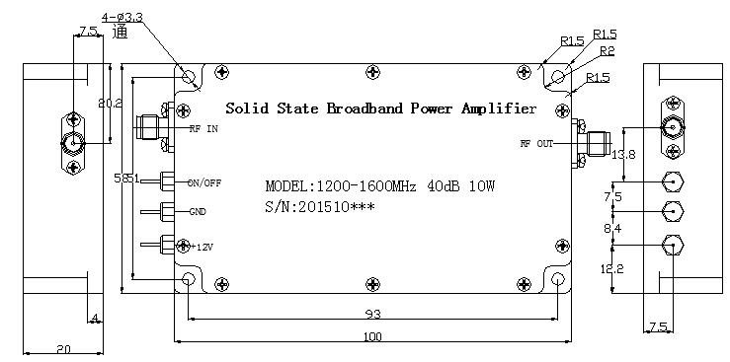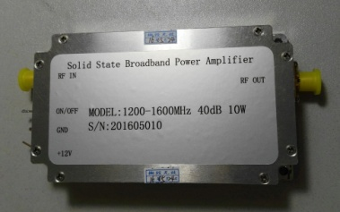

PA12681624_40(10W)
Frequency Range: 1268 ～ 1624 MHz
Launch Output：40±2 dBm（Full band）
Gain：40±2.5 dB
Small Signal Gain Flatness：Peak to Peak ≤3dB
Harmonics：9K～1GHz: ≤-36dBm/30KHz
Input VSWR：≤1.80
Supply Voltage：＋27V DC
Power Consumption: ≤2.5 A @27V
Operating Temp.：-10℃ ～ +55℃
Dimensions：178*91*24(mm)
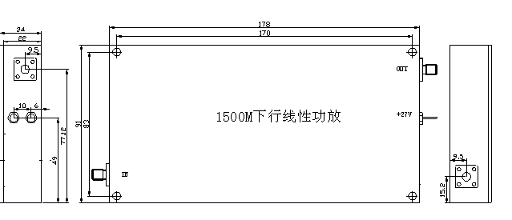
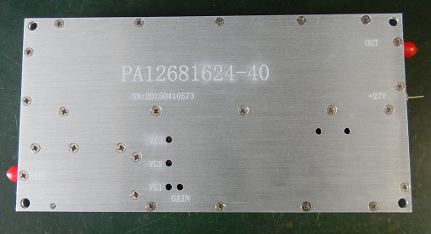

PA14201454_27(0.5W)
Frequency Range: 1420 ～ 1454 MHz
Launch Output：≥27dBm
Gain：49±1dB
Small Signal Gain Flatness：Peak to Peak 1dB
Launch Power Input：-18±2.0dBm
Output Shoulder Ratio：≥-40dBc
Input/Output impedance：50 Ohm
Supply Voltage：＋7.2~18Vdc
Power Consumption: ≤5W (0.35 A @12V)
Operating Temp.：-20℃ ～ +60℃
Dimensions：60*35*20(mm)
Weight： 100g
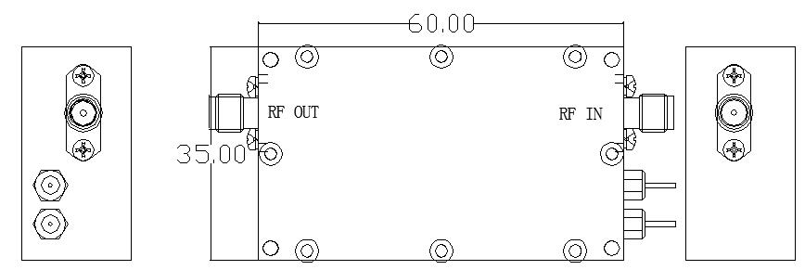

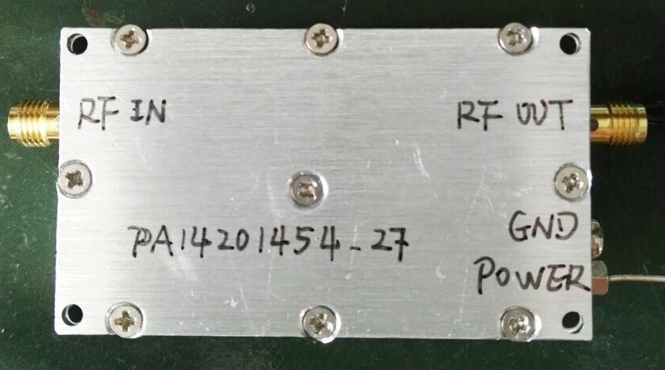

PA15001700_50(100W)
Frequency Range: 1500 ～ 1700 MHz
Launch Output：≥50dBm
Gain：50 ± 1 dB
Small Signal Gain Flatness：Peak to Peak 2dB
Launch Power Input：Min. 0dBm
Input/Output VSWR：≤1.5:1
Input/Output impedance：50 Ohm
Power Supply: DC 24V
ON/OFF Control：ON/Low Level or GND;OFF/High Level
Operating Temp.：-25℃ ～ +60℃
Dimensions：1950*150*25(mm)
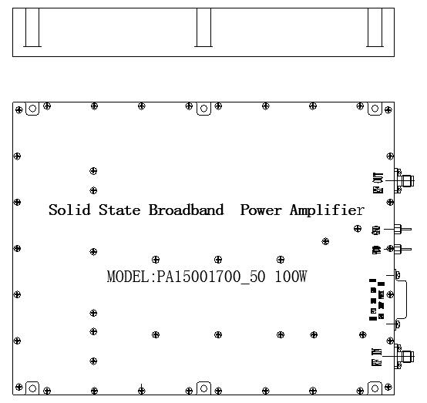
PA19301990_45(32W)
Operating Frequency：1940MHz～1990MHz
Launch Output：32W（CW）
Transmit Gain：40± 1 dB
Small Signal Gain Flatness：Peak to Peak 2dB Over Freq Band
Gain Stability：± 1.50dB Over Temp.
Input/Output VSWR：≤1.5:1
Input/Output impedance：50 Ohm
Power Consumption：: 3A @28V
RF Connectors）： SMA Female
Operating Temp.：-20℃ ～ +60℃
I/O Map：D-Sub 9 Pin
Dimensions：100*100*30(mm) excluding connectors
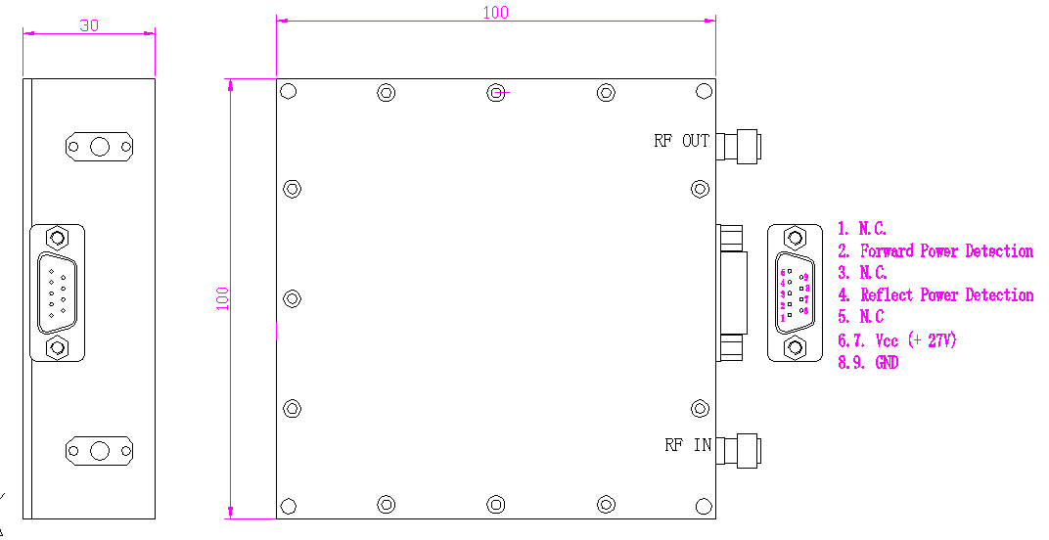

PA21102170_34(2W)
Frequency Range: 2110 ～ 2170 MHz
Launch Output：≥34dBm
Small Signal Gain：20dB Minimum - 23dB Maximum
Input/Output VSWR：≤1.5:1
Input/Output impedance：50 Ohm
Power Supply: Minimum 12.0V, Maximum 16.5V
DC Current：1.8A Maximum
RF Connectors： SMA Female
Operating Temp.：-20℃ ～ +60℃
Dimensions（excluding connectors）：58*47*15(mm)
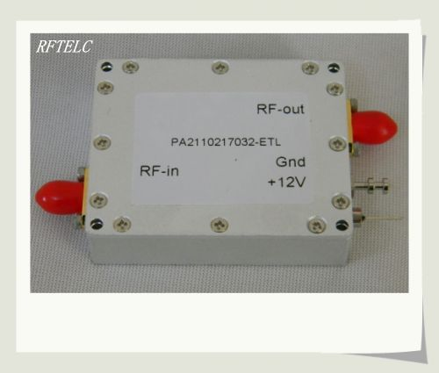

PA869960_30(1W)
Frequency Range: 869 ～ 960 MHz
Launch Output： 30dBm
Small Signal Gain：15±1dB
Input/Output VSWR：≤1.5:1
Input/Output impedance：50 Ohm
Power Supply: Minimum 12.0V, Maximum 16.5V
DC Current：400mA Maximum
RF Connectors： SMA Female
Operating Temp.：-20℃ ～ +60℃
Dimensions（excluding connectors）：58*47*15(mm)

PA18051990_30(1W)
Frequency Range: 1805 ～ 1990 MHz
Launch Output： 30dBm
Small Signal Gain：14±1dB
Input/Output VSWR：≤1.5:1
Input/Output impedance：50 Ohm
Power Supply: Minimum 12.0V, Maximum 16.5V
DC Current：400mA Maximum
RF Connectors： SMA Female
Operating Temp.：-20℃ ～ +60℃
Dimensions（excluding connectors）：58*47*15(mm)

PA21102170_47(60W)
Operating Frequency：2110MHz～2170MHz
Launch Output：60W（CW）
Transmit Gain：45± 1 dB
Small Signal Gain Flatness：Peak to Peak 2dB Over Freq Band
Gain Stability：± 1.50dB Over Temp.
Input/Output VSWR：≤1.5:1
Input/Output impedance：50 Ohm
Power Consumption：: 6.5A @28V
RF Connectors）： SMA Female
Operating Temp.：-20℃ ～ +60℃
I/O Map：D-Sub 9 Pin
Dimensions：100*120*30(mm) excluding connectors
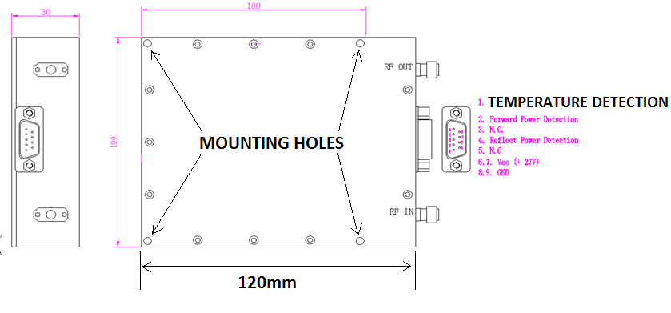

PA24002480_40(10W)
Frequency Range: 2400 ～ 2480 MHz
Launch Output：≥40dBm
Gain：40 ± 1 dB
Small Signal Gain Flatness：Peak to Peak 2dB
Launch Power Input：Min. 0dBm
Gain Stability)：± 1.50dB
Input/Output VSWR：≤1.5:1
Input/Output impedance：50 Ohm
Power Consumption: 2.5A @ DC 12V
Indicating lamp : Red
Operating Temp.：-40℃ ～ +60℃
Dimensions：110*120*25 (mm)
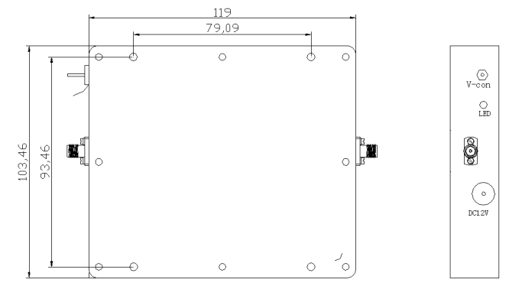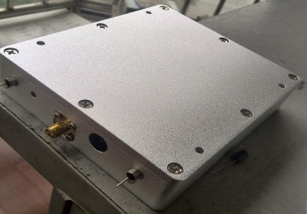

PA24002500_50(100W)
Frequency Range: 2400 ～ 2500 MHz
Launch Output：≥50dBm
Gain：≥50dB
Small Signal Gain Flatness：± 1.5 dB
Launch Power Input：Min. 0dBm
Input VSWR：≤1.5:1
Input/Output impedance：50 Ohm
Power Consumption: 12A @ DC 28V
Efficiency: ≥25%
RF Connnector：N Female (50Ω)
Operating Temp.：-20℃ ～ +60℃
Temp. Protection：Switch Off @≥62℃
ON/OFF Control：Default ON, Switch Off @ Low Level
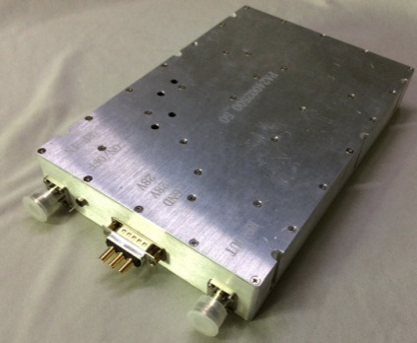
Dimensions：236*156*35 (mm)
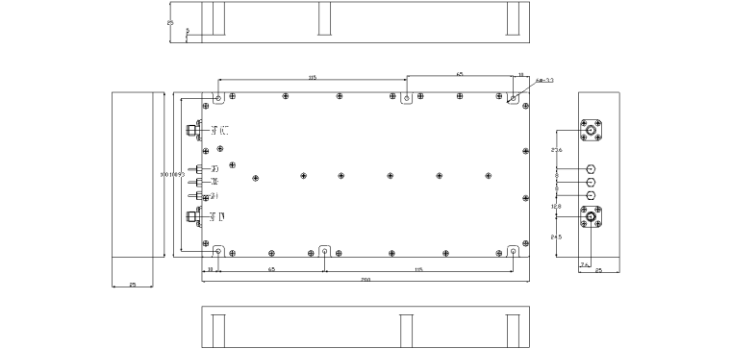
PA26002700_37(5W)
Operating Frequency：2600MHz～2700MHz
Launch Output：37 dBm（CW）
Transmit Gain：35± 1 dB
Small Signal Gain Flatness：Peak to Peak 2dB Over Freq Band
Gain Stability：± 2.0dB Over Temp.
Input/Output VSWR：≤1.5:1
Input/Output impedance：50 Ohm
Power Consumption：: 0.7A @28V
RF Connectors）： SMA Female
Operating Temp.：-20℃ ～ +60℃
I/O Map：D-Sub 9 Pin
Dimensions：100*100*30(mm) excluding connectors
PA26002700_45(32W)
Operating Frequency：2600MHz～2700MHz
Launch Output：> 45 dBm（CW）
Transmit Gain：40± 1 dB
Small Signal Gain Flatness：Peak to Peak 2dB Over Freq Band
Gain Stability：± 1.5 dB Over Temp.
Input/Output VSWR：≤1.5:1
Input/Output impedance：50 Ohm
Power Consumption：: 4.4A @28V
RF Connectors）： SMA Female
Operating Temp.：-20℃ ～ +60℃
I/O Map：D-Sub 9 Pin
Dimensions：100*100*30(mm) excluding connectors

PA340470_33(2W)
Frequency Range: 340 ～ 470 MHz
Launch Output：≥33dBm(2W @COFDM Signal)
Gain：≥13dB
Small Signal Gain Flatness：≤2.0dB
Input/Output impedance：50 Ohm
Power Consumption: 1.5A @ DC 12V
RF Connnector：SMA Female (50Ω)
Operating Temp.：-20℃ ～ +70℃
ON/OFF Control：Switch ON @ High Level 3.3v
Dimensions：90*48.8*12.5 (mm)
Net Weight: 150g
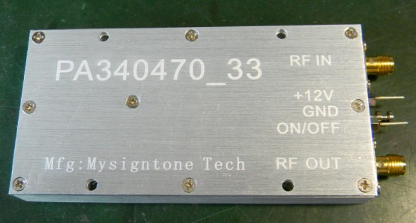
PA450600_33(2W)
Frequency Range: 450 ～ 600 MHz
Launch Output：≥33dBm(2W @COFDM Signal)
Gain：≥13dB
Small Signal Gain Flatness：≤2.0dB
Input/Output impedance：50 Ohm
Power Consumption: 1.5A @ DC 12V
RF Connnector：SMA Female (50Ω)
Operating Temp.：-20℃ ～ +70℃
ON/OFF Control：Switch ON @ High Level 3.3v
Dimensions：90*48.8*12.5 (mm)
Net Weight: 150g

PA57005900_42(15W)
Frequency Range: 5700 ～ 5900 MHz
Launch Output：≥42dBm(15W)
Gain：≥44dB
Small Signal Gain Flatness：Peak to Peak 2dB
Launch Power Input: -2 dBm
In/Out VSWR：≤1.5:1
Power Consumption: 2A @ DC 24V /42 dBm
RF Connnector：SMA Female (50Ω)
Operating Temp.：-10℃ ～ +40℃
Dimensions：185*45*20 (mm)

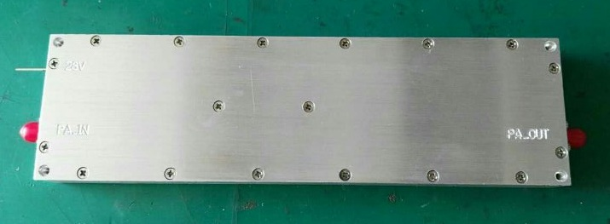

PA57005850_50(100W)
Frequency Range: 5700 ～ 5850 MHz
Launch Output：≥50 dBm(100W)
Gain：50±1 dB
Small Signal Gain Flatness：± 1.5 dB
Launch Power Input: 0 dBm
Power Consumption: ≤13A @ DC 28V
RF In Connnector：SMA Female (50Ω)
RF Out Connnector：N Female (50Ω)
Operating Temp.：-20℃ ～ +50℃
Dimensions：220*120*25 (mm)
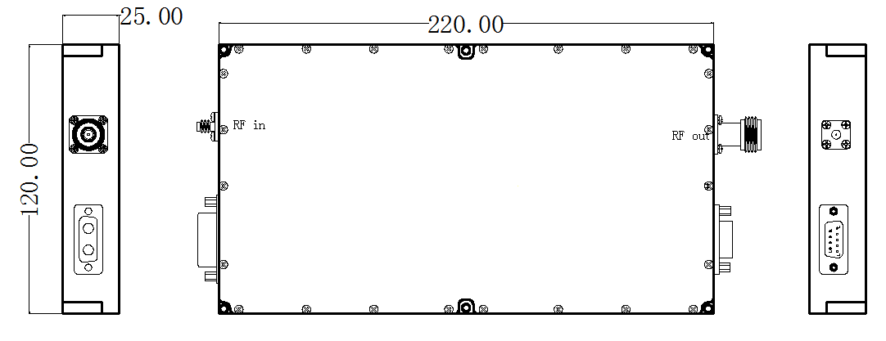
TDD24002500_33(2W)
Frequency Range: 2.4～2.5GHz
Working Pattern: TDD
Launch Output: 33dBm (2w)
Launch Power Input: Min: 5 dBm～Max: 17 dBm
Switch On Power Input (Customized): Max: -5 dBm
Transmit Gain: 19 dB typical
Receive Gain: 16 dB typical
Small Signal Gain Flatness: ±1dB
Noise Figure: ＜3.0dB
Switch time delay: ＜1us
AGC Control :Enable
RF Connectors: SMA-K-(50Ω)
Operating Temp.: -25℃ ～ +55℃
Indicating lamp: Green / Red
Power Consumption: 1A @ DC 12V
Dimensions: 92*82*24(mm)
Weight: 400g
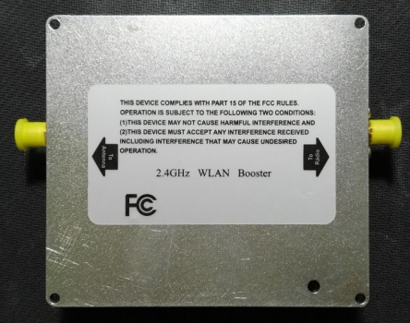
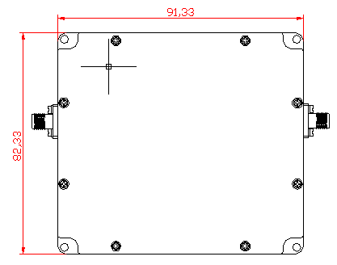

TDD24002500_27(0.5W)_1T2R
Frequency Range: 2.4～2.5GHz
Working Pattern: TDD
Launch Output: 27dBm (0.5w @ 2 way Total Output Power)
Launch Power Input: Min: 5 dBm～Max: 16 dBm
Transmit Gain: 15 dB typical
Receive Gain: 14 dB typical
Small Signal Gain Flatness: ±1dB
Noise Figure: ＜6.5dB
Switch time delay: ＜1us
RF Connectors: SMA-K-(50Ω)
Operating Temp.: -25℃ ～ +55℃
Indicating lamp: Green / Red
Power Consumption: 0.5A @ DC 12V
Dimensions: 90*60*20(mm)
Weight(g): 300g
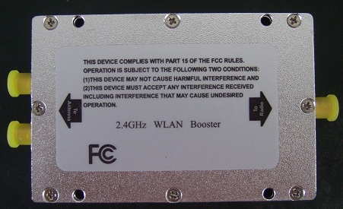

TDD24002500_40(10W)
Frequency Range: 2.4～2.5GHz
Working Pattern: TDD
Launch Output: 40dBm (10w)
Launch Power Input: Min: 5 dBm～Max: 20 dBm
Transmit Gain: 22 dB typical
Receive Gain: 18 dB typical
Small Signal Gain Flatness: ±1dB
Noise Figure: ＜3.0dB
Switch time delay: ＜1us
AGC Control : Enable
RF Connectors: SMA-K-(50Ω)
Operating Temp.: -25℃ ～ +55℃
Indicating lamp: Green / Red
Power Consumption: 4A @ DC 28V
Dimensions: 150*170*24 (mm)
Weight(g): 900g

TDD34003600_37(5W)
工作频段(Frequency Range): 3.4～3.6GHz
工作模式(Working Pattern): TDD
发射功率(Launch Output):Max 37dBm (5w)
输入功率(Launch Power Input): Min:5 dBm～Max:25 dBm
发射增益(Transmit Gain): 12 dB typical
接收增益(Receive Gain): 14 dB typical
驻波 VSWR：≤1.8
噪声系数(Noise Figure): ＜3.5dB
开关延时(Switch time delay): ＜1us
射频接头(RF Connectors): N-K-(50Ω)
工作温度(Operating Temp. ): -25℃ ～ +55℃
指示灯(Indicating lamp): Green / Red
功耗(Power Consumption): 2A @ DC 28V
尺寸(Dimensions): 128*156*27(mm)
净重(Weight): 1000g
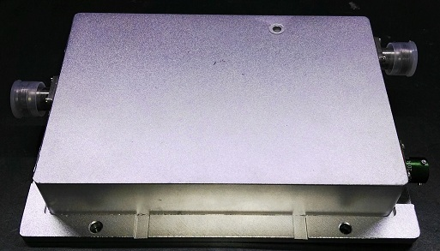
TDD750790_43(20W)
工作频段(Frequency Range): 750～790 MHz
工作模式(Working Pattern): TDD
发射功率(Launch Output):Max 43dBm (20w)
输入功率(Launch Power Input): Min:10 dBm～Max:28 dBm
发射增益(Transmit Gain): >12 dB
接收增益(Receive Gain): 15 dB typical
噪声系数(Noise Figure): ＜3.0 dB
开关延时(Switch time delay): ＜1us
射频接头(RF Connectors): SMA-K-(50Ω)
工作温度(Operating Temp. ): -25℃ ～ +55℃
指示灯(Indicating lamp): Green / Red
功耗(Power Consumption): 1.3A @ DC 28V
尺寸(Dimensions): 140*65*20(mm)
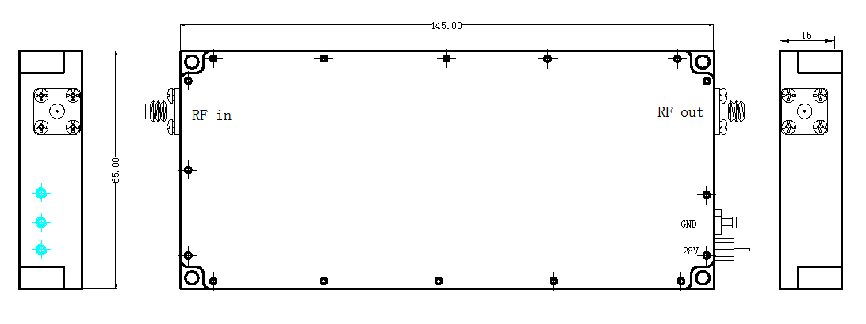
TDD890935_37(5W)
工作频段(Frequency Range): 890-935MHz
工作模式(Working Pattern): TDD
发射功率(Launch Output): >37dBm
输入功率(Launch Power Input): Min:10 dBm～Max:27 dBm
发射增益(Transmit Gain): >13dB
接收增益(Receive Gain): >10dB
噪声系数(Noise Figure): ＜3.0 dB
开关延时(Switch time delay): ＜1us
射频接头(RF Connectors): SMA-K-(50Ω)
工作温度(Operating Temp. ): -25℃ ～ +55℃
功耗(Power Consumption): 5A @ DC 12V
尺寸(Dimensions): 86*66*20(mm)
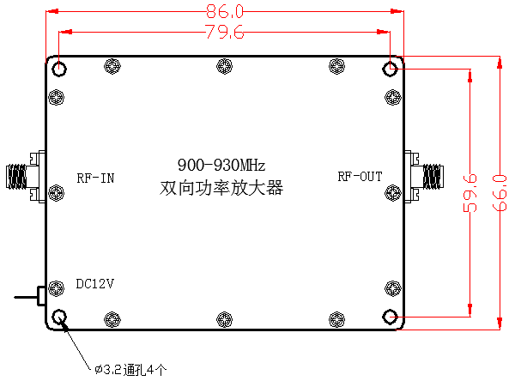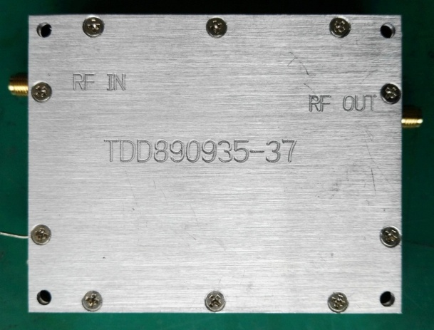

LTE23002400_40(10W)
工作频段(Frequency Range): 2.3～2.4GHz
工作模式(Working Pattern): TDD
发射功率(Launch Output):Max 41dBm (10w)
输入功率(Launch Power Input): Min:5 dBm～Max:25 dBm
发射增益(Transmit Gain): 50 dB typical
接收增益(Receive Gain): 12 dB typical
驻波 VSWR：≤1.5
开关延时(Switch time delay): ＜1us
射频接头(RF Connectors): SMA-K-(50Ω)
工作温度(Operating Temp. ): -25℃ ～ +55℃
功耗(Power Consumption): 8A @ DC 28V
尺寸(Dimensions): 286*187*21(mm)
净重(Weight): 2000g
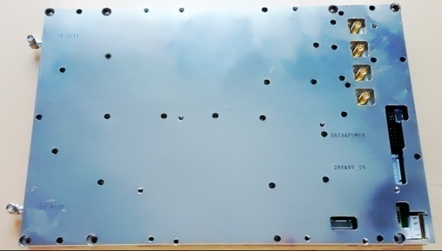

此规格书参数同样适合用于LTE1880～1920MHz & LTE2580～2620MHz

TDDSF335345_40(10W)
工作频段(Frequency Range): 335～345 MHz/ 2462MHz
工作模式(Working Pattern): TDD
发射功率(Launch Output): 40dBm (10w) @340MHz
输入功率(Launch Power Input): Min:7 dBm～Max:17 dBm (@2462MHz)
发射增益(Transmit Gain): >30 dB
接收增益(Receive Gain): 10 dB typical
噪声系数(Noise Figure): ＜3.0 dB
开关延时(Switch time delay): ＜1us
射频接头(RF Connectors): SMA-K-(50Ω)
工作温度(Operating Temp. ): -25℃ ～ +55℃
指示灯(Indicating lamp): Green / Red
功耗(Power Consumption):3A @ DC 12V
尺寸(Dimensions): 87*66*22(mm)
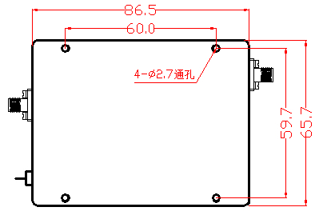

特点：将2.4G wifi信号变频至340MHz 低频，利用低频的绕射能力，来增强数据在复杂环境下的传输（如楼梯上下层之间、地下车库、煤矿、巷道等）。

